**ISEM 3006 Data Management in Business**

**Exercise 5**

**SQL SELECT Answers**

**Use the Trustful Property Rental Company Database in Exercise 3.**

**Use PostgreSQL SELECT statement to answer the following queries.**

**Unless state otherwise, the case of strings is important, i.e. if I ask you to retrieve properties that are located in 'KLN', you only retrieve properties that are located in 'KLN', but not 'kln', 'Kln', 'kLn', etc.**

1. For each of the employee who is in charge of properties, list his/her name, employeeID, and the total number of viewings of all the properties for which he/she is in charge of. Only list those employees that has total number of viewings greater than 6.

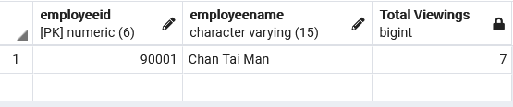

SELECT E.EmployeeID, E.EmployeeName,

Count(*) AS "Total Viewings"

FROM Employee E JOIN Property P

ON E.EmployeeID = P.EmployeeID

JOIN Viewing V

ON P.PropertyNo = V.PropertyNo

GROUP BY E.EmployeeID, E.EmployeeName

HAVING count(*) > 6;

1. List the owner number and name of the property owners who have listed ‘Flat’ located in the city ‘KLN’ BUT HAVE NOT listed ‘Flat’ located in the city ‘HK’.

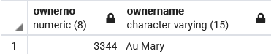

SELECT PO.OwnerNo, PO.OwnerName

FROM Property P JOIN PropertyOwner PO

ON P.OwnerNo = PO.OwnerNo

WHERE Type = 'Flat' AND PropertyCity ='KLN'

EXCEPT

SELECT PO.OwnerNo, PO.OwnerName

FROM Property P JOIN PropertyOwner PO

ON P.OwnerNo = PO.OwnerNo

WHERE Type = 'Flat' AND PropertyCity ='HK' ;

1. List the property number, ownerno, monthly rental, and the name of the ‘in-charge’ employee for those property having a monthly rental less than the average of the monthly rental of all the properties.

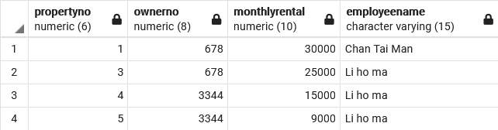

SELECT P.PropertyNo, P.OwnerNo, P.MonthlyRental,

E.EmployeeName

FROM Property P JOIN Employee E

ON P.EmployeeID = E.EmployeeID

WHERE P.MonthlyRental < (SELECT AVG(MonthlyRental)

FROM Property );

1. For properties that have viewing, list the property no, property street, and the number of viewings it has. Only list those properties that have the number of viewings that is more than number of viewings of the property with propertyno = 4.

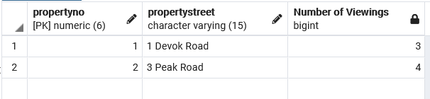

SELECT P.PropertyNo, P.PropertyStreet,

COUNT(*) AS "Number of Viewings"

FROM Viewing V JOIN Property P

ON P.PropertyNo = V.PropertyNo

GROUP BY P.PropertyNo, P.PropertyStreet

HAVING COUNT(*) > (SELECT COUNT(ViewingNo)

FROM Viewing

WHERE PropertyNo = 4) ;

1. List the Employee ID and the name of the employees who have not been in charge of any property.
   1. using outer join
   2. using EXCEPT (set operation)
   3. using subquery (DON"T use OUTER JOIN or EXCEPT in this answer)

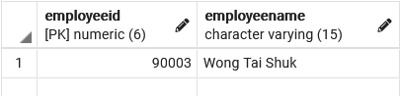

a.

SELECT E.EmployeeID, E.EmployeeName

FROM Employee E LEFT OUTER JOIN Property P

ON E.EmployeeID = P.EmployeeID

WHERE P.PropertyNo is NULL ;

b.

SELECT EmployeeID, EmployeeName

FROM Employee

EXCEPT

SELECT E.EmployeeID, E.EmployeeName

FROM Employee E JOIN Property P

ON E.EmployeeID = P.EmployeeID ;

c.

SELECT EmployeeID, EmployeeName

FROM Employee

WHERE EmployeeID NOT IN (SELECT EmployeeID

FROM Property) ;

1. List the client number, client name, and the number of properties that he/she have viewed for those clients who have viewed ALL the properties. (Note a client may view the same property many time.)

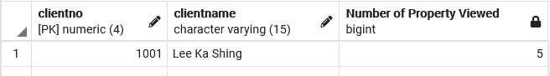

SELECT C.ClientNo, ClientName,

COUNT(distinct V.PropertyNo) AS "Number of Property Viewed"

FROM Client C JOIN Viewing V

ON C.ClientNo = V.ClientNo

GROUP BY C.ClientNo, ClientName

HAVING COUNT(distinct V.PropertyNo) = (SELECT COUNT(*)

FROM Property);

1. List the client number, client name, and the number of properties that he/she have viewed for those clients who have viewed ALL the properties located in the city ‘HK’. (Note a client may view the same property many time.)

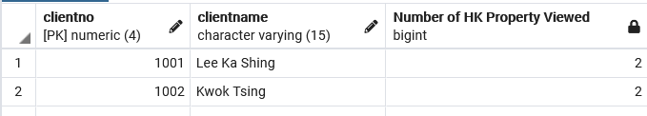

SELECT C.ClientNo, C.ClientName,

COUNT(distinct V.PropertyNo) AS "Number of HK Property Viewed"

FROM Client C JOIN Viewing V

ON C.ClientNo = V.ClientNo

JOIN Property P

ON V.PropertyNo = P.PropertyNo

WHERE PropertyCity = 'HK'

GROUP BY C.ClientNo, C.ClientName

HAVING COUNT(distinct V.PropertyNo) = (SELECT COUNT(*)

FROM Property

WHERE PropertyCity = 'HK');

The subquery return the number of properties located in ‘HK’

This is the number of ‘HK’ properties viewed by each of the client.

1. List the owner name, property number, property street address, and the monthly rental for the 2 properties which have the highest monthly rental. You should take care of ties, i.e., if a property has the monthly rental as the 2nd property, it should also be included in the result. Order the output by monthly rental in descending order. (Even though there is no tie in this particular set of data, your answer need to take care of the tie.)

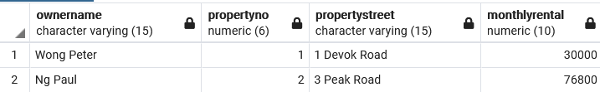

SELECT PO.OwnerName, P.PropertyNo, P.PropertyStreet, P.MonthlyRental

FROM Property P JOIN PropertyOwner PO

ON P.OwnerNo = PO.OwnerNo

WHERE MonthlyRental IN (SELECT MonthlyRental

FROM Property

ORDER BY MonthlyRental DESC

FETCH FIRST 2 ROW ONLY)

ORDER BY MonthlyRental DESC;

The output table should look like the following. I mistakenly place the wrong output table in the question.

